**Title:** Implementation of rectifier circuits and analysis of OR gate and justification of the analysis with respect to simulated and experimental data (followed by the given constraints).

**Objective**: Design a full wave rectifier which gives the stable DC voltage and use this DC voltage to see the different logic gates implementation.

**Theory:**

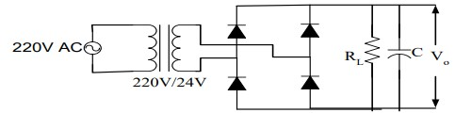

# Full wave bridge rectifier

Working Principle of Full-Wave rectifier: The Bridge rectifier is a circuit, which converts an ac voltage to dc voltage using both half cycles of the input ac voltage. The Bridge rectifier circuit is shown in the following figure. The circuit has four diodes connected to form a bridge. The ac input voltage is applied to the diagonally opposite ends of the bridge. The load resistance is connected between the other two ends of the bridge. For the positive half cycle of the input ac voltage, diodes D1 and D2 conduct, whereas diodes D3 and D4 remain in the OFF state. The conducting diodes will be in series with the load resistance RL and hence the load current flows through RL. For the negative half cycle of the input ac voltage, diodes D3 and D4 conduct whereas, D1 and D2 remain OFF. The conducting diodes D3 and D4 will be in series with the load resistance RL and hence the current flows through RL in the same direction as in the previous half cycle. Thus, a bidirectional wave is converted into a unidirectional wave.

OR gate:

Logic gates are the elementary building blocks of a digital circuit. They are the practical applications of Boolean Algebra. These logic gates or circuits take one or more inputs and generally give one output. OR gate is one of the basic logic gates. An OR gate operates on two or more inputs and gives one output. It gives a high output (1) if any of the inputs are high (1) and a low output (0) when all the inputs are low (0).

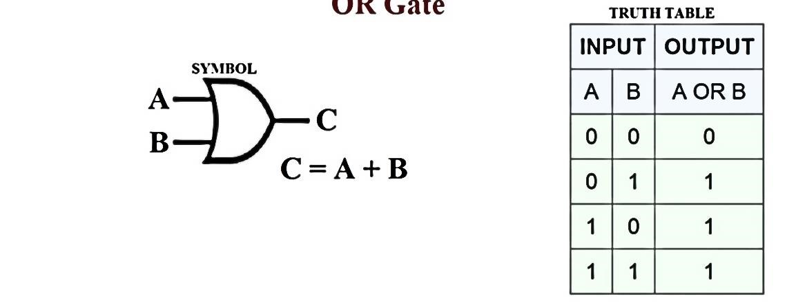

Logic expression: The output of a OR gate is LOW whenever two inputs are LOW, otherwise it is HIGH.

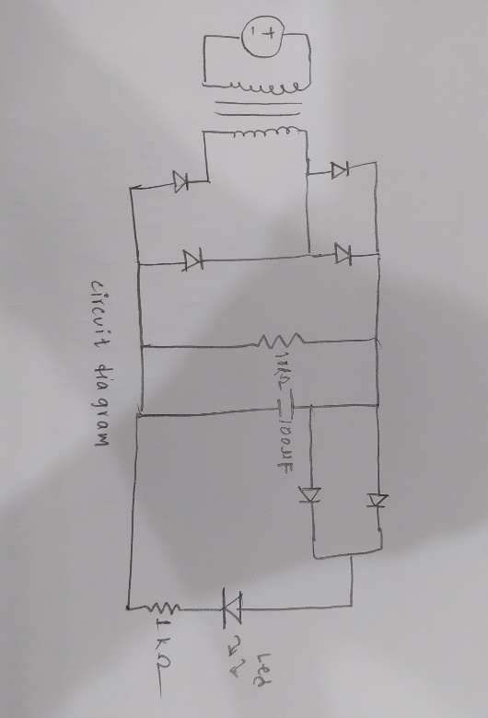

**Circuit diagram:**

**Apparatus**

|  |  |  |
| --- | --- | --- |
| **Apparatus** |  | **Quantity** |
| Diode | 6 |  |
| Trainer board | 1 |  |
| Resistors | 2 |  |
| Oscilloscope | 1 |  |
| Multimeter | 1 |  |
| Capacitors | 1 |  |
| DC Power Supply | 1 |  |

**Simulation:**

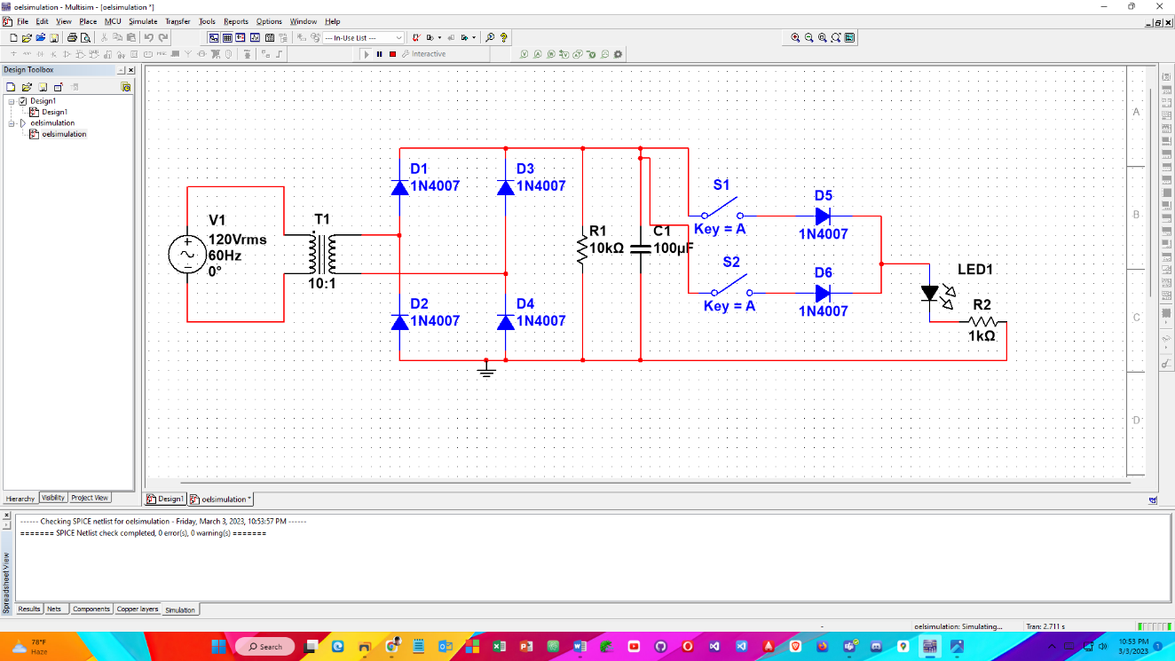for input A = 0 & B = 0:

For input A = 0 & B = 1:

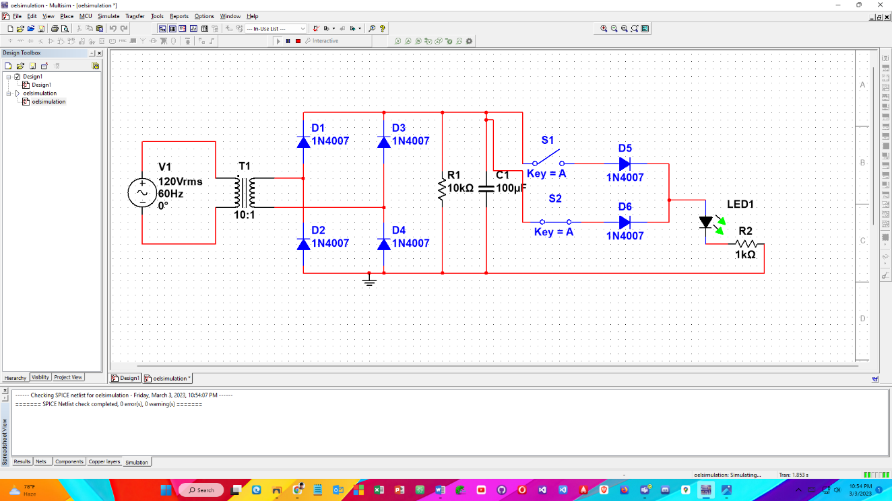

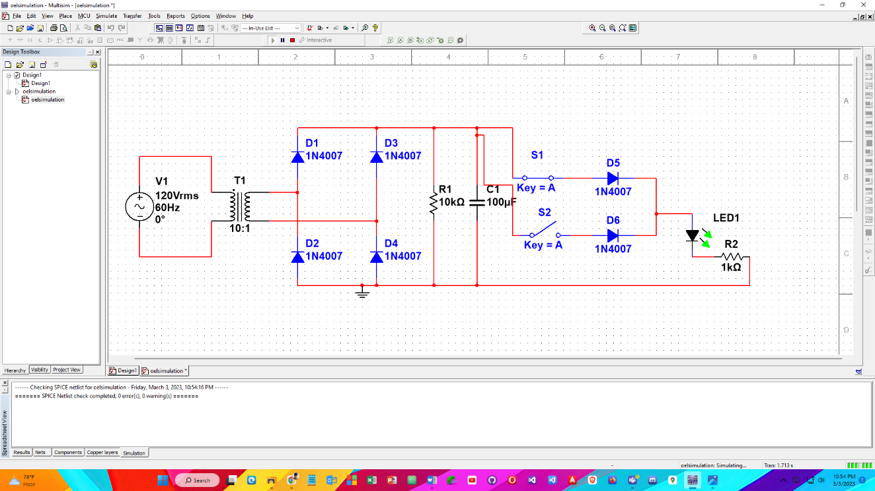For input A = 1 & B = 0:

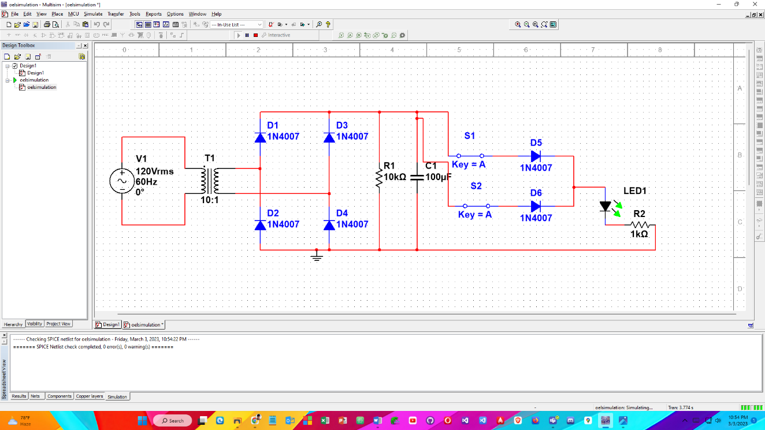For input A = 1 & B =1: